**CHAPTER 1: LED**

*Learning Objectives:*

1. *To introduce the students to LED as basic output device.*
2. *To introduce the students to Arduino programming to control LED.*
3. *To familiarize the students to LED circuit.*

**Inputs and Outputs to Digital System**

Every digital system has inputs and outputs. The input is what sets a digital system in action. Meanwhile, the output is what results from the system. There are various type of input and output devices. Example of input devices include the sensors, communication modules, external storage and many more. Example of output devices include lights, sound, actuators, communication module, display and many more.

**Light as Output**

Electric light is widely used in our daily live. Types of electric lighting include:

* incandescent light bulbs
* gas-discharge lamps, e.g., fluorescent lights
* light-emitting diodes

In digital system, light is normally used to give signal or indication (output). LED is always used as output device in digital system.

**Light Emitting Diode**

Light-Emitting Diode or popularly known as LED is a p–n junction diode, which emits light when activated. The color of emitted light can be Red, Green or Yellow by depending on the way the diode is produced. LEDs are commonly used for indicator lights (such as power on/off lights) on electronic devices. They also have several other applications, including electronic signs, clock displays, and flashlights. You can typically identify LEDs by a series of small lights that make up a larger display. For example, if you look closely at a street light, you can tell it is an LED light if each circle is comprised of a series of dots.

Recent developments in LEDs permit them to be used in environmental and task lighting. LEDs have many advantages over incandescent light sources including lower energy consumption, longer lifetime, improved physical robustness, smaller size, and faster switching. Light-emitting diodes are now used in applications as diverse as aviation lighting, automotive headlamps, advertising, general lighting, traffic signals, camera flashes and lighted wallpaper.

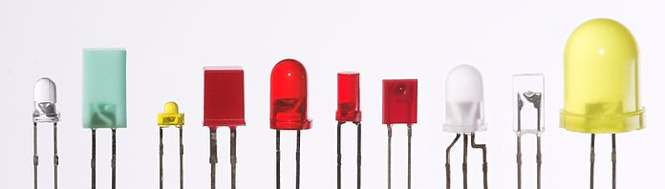

Figure 1: Different looks of LED

As with all diodes, current in LED flows from only in one direction, from anode to cathode.

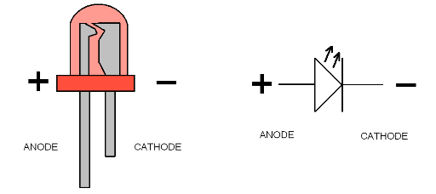

Figure 2: LED pins and symbol

HBE Arduino-Sensor board is equipped with several push buttons. Refer to Chapter 10 of the HBE Arduino-Sensor text book to read more regarding the push button and to get to know the push buttons used on the HBE Arduino Sensor board.

**Practice 1.1: LED Control**

In this first activity, we will try to experiment with the LEDs on the HBE Arduino –Sensor board. We will write a program that can blink the LED.

**Instructions:**

1. Write Arduino program below on the Arduino IDE:

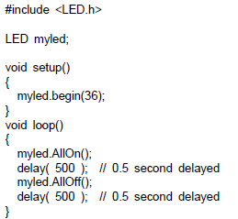

1. Upload the program onto the Arduino Mega of the HE Arduino-Sensor board and observe the LEDs.
2. Then write the following program and upload it:

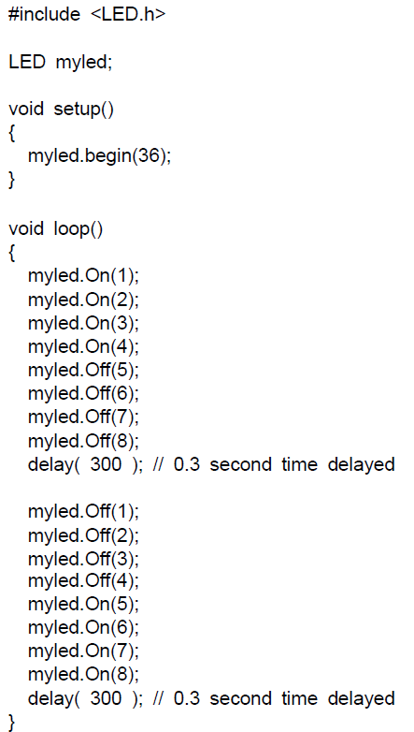



1. Now try to modify the program so that the LED blink one by one from 1 to 8.

**Practice 1.2: LED Circuit – The Traffic Light**

Now in this second activity, we are going to construct LED circuit and control it by using the Arduino UNO. The circuit will consist of three LEDs that represent a traffic light system.

**Instructions:**

1. Construct circuit consisting of 3 LEDs (red, yellow and green) by following the schematic below. Use the breadboard and Arduino UNO port 5,6 and 7.

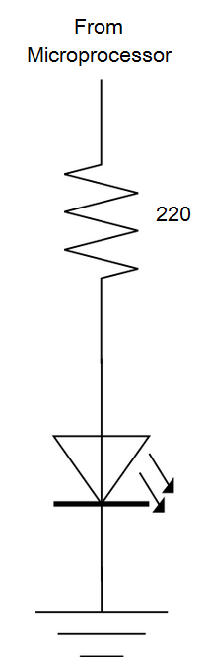

1. Write a program to control the LEDs so that it behave similar to the traffic light system. (Green ON for 5 seconds -> Red ON for 10 seconds -> Yellow ON for 1 second). Since we are not using he HBE Arduino-Sensor board, use a digitalWrite() function and select your port correctly.